AWS TASK3

1.Create a S3 bucket, with no public access and upload files to the bucket & view the logs using cloudwatch for the uploaded files.

Created the 2 S3 bucket without public access.
One is for storing the files actual S3 and another it’s for Storing the logs of actual S3.

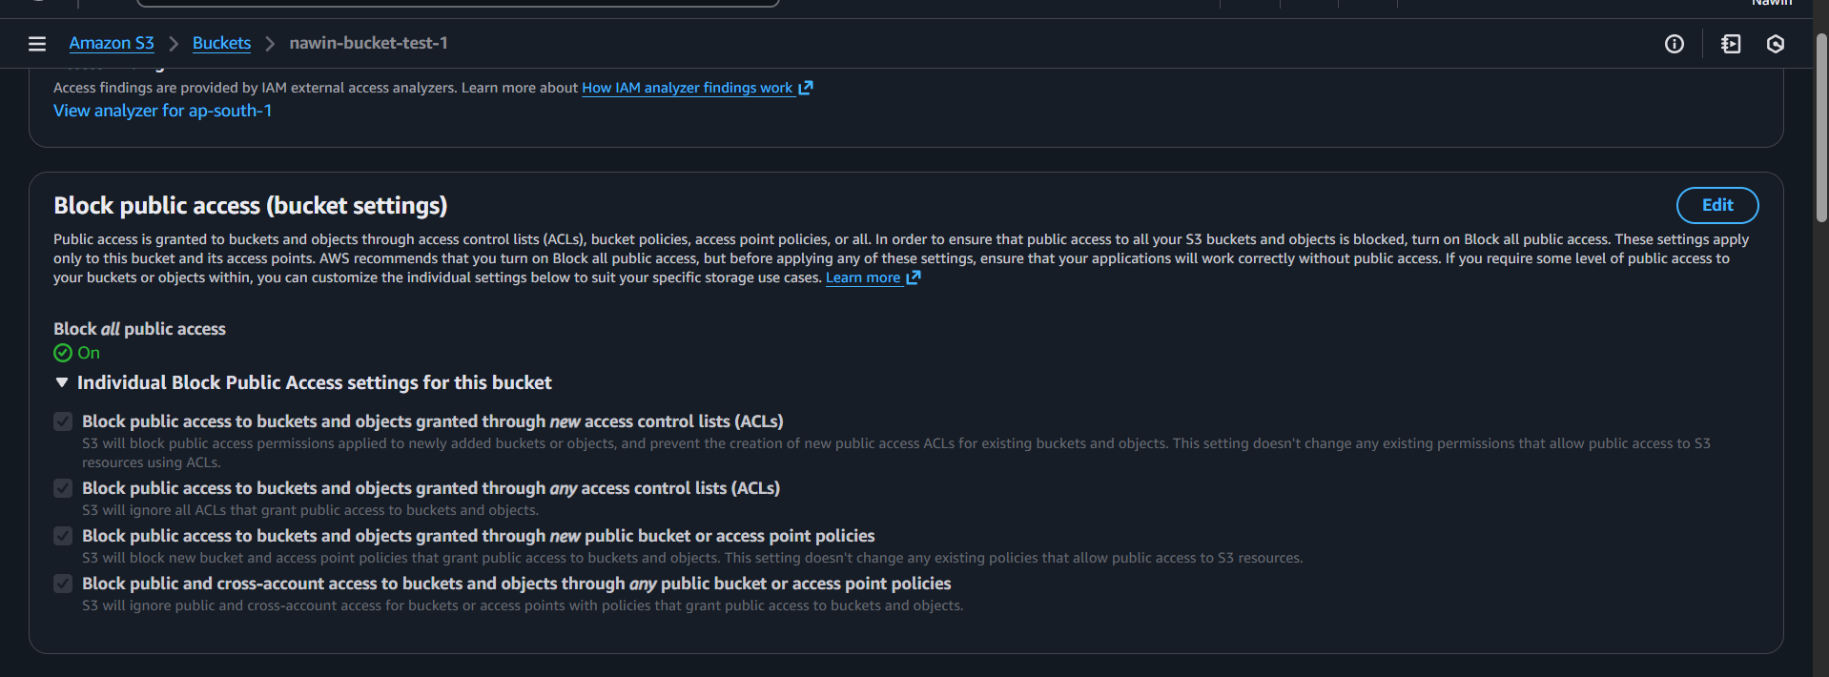

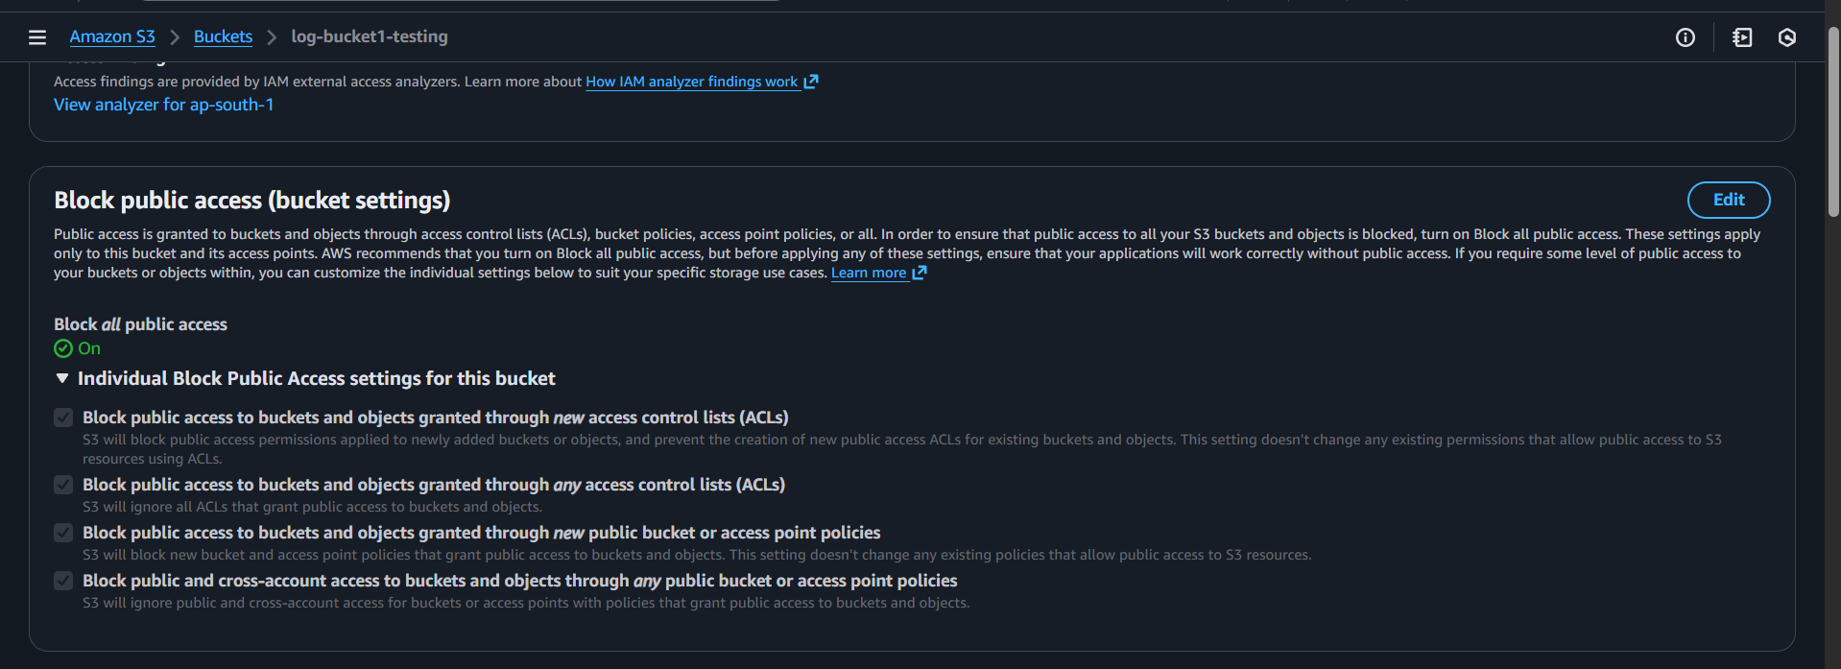

Created the Cloud Trail to fetch the logs from the Cloud watch

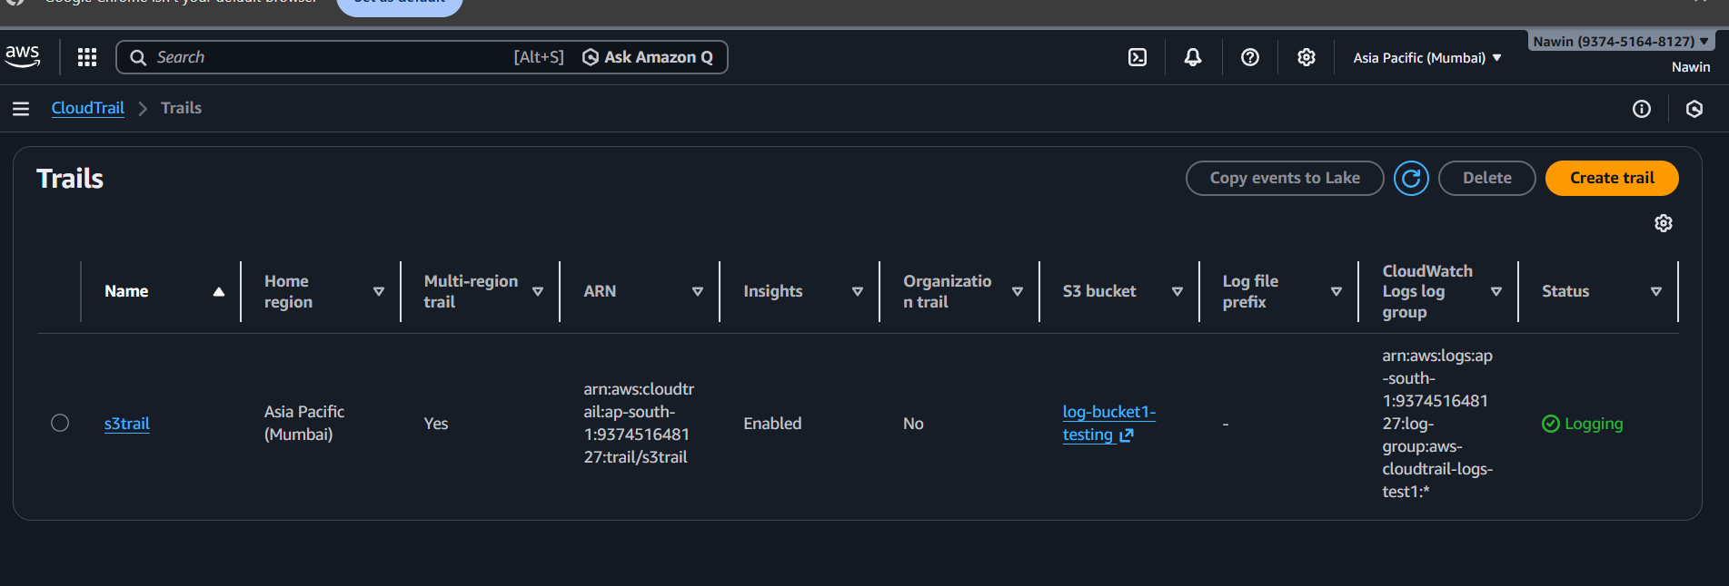

In this Created Log group for log stream and its updated Cloud Watch

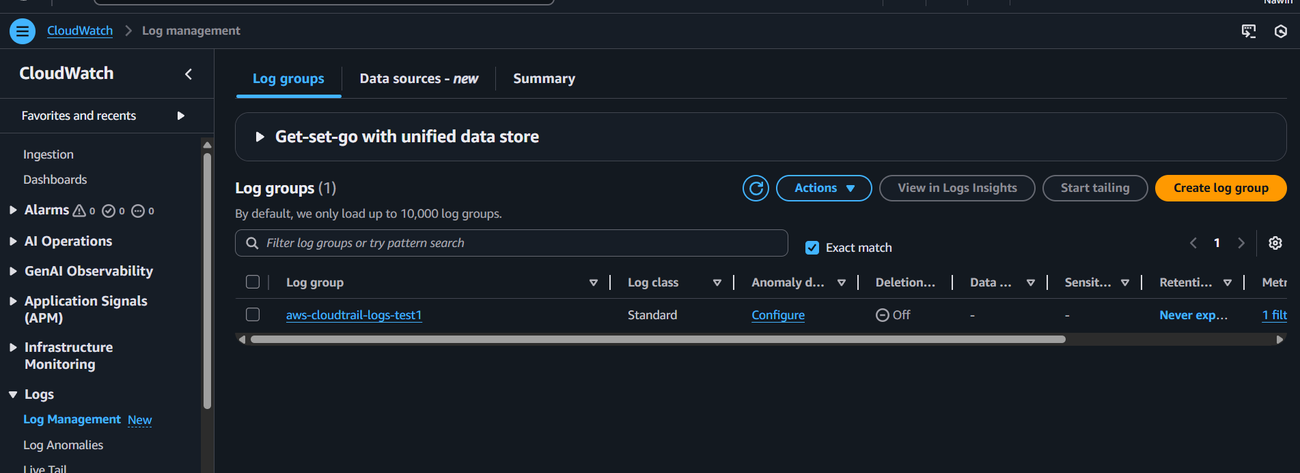

We can be able to see the Log streaming
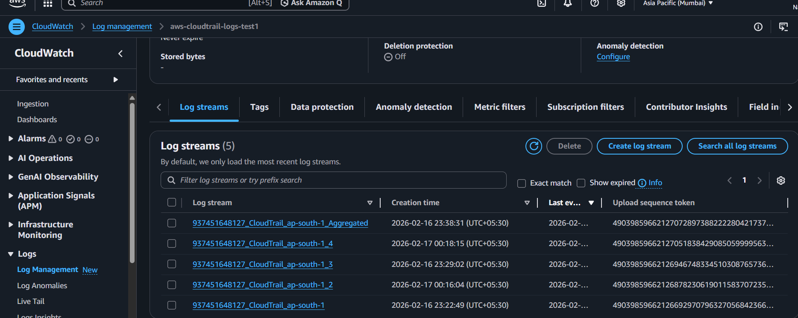
Uploaded the file in S3 bucket
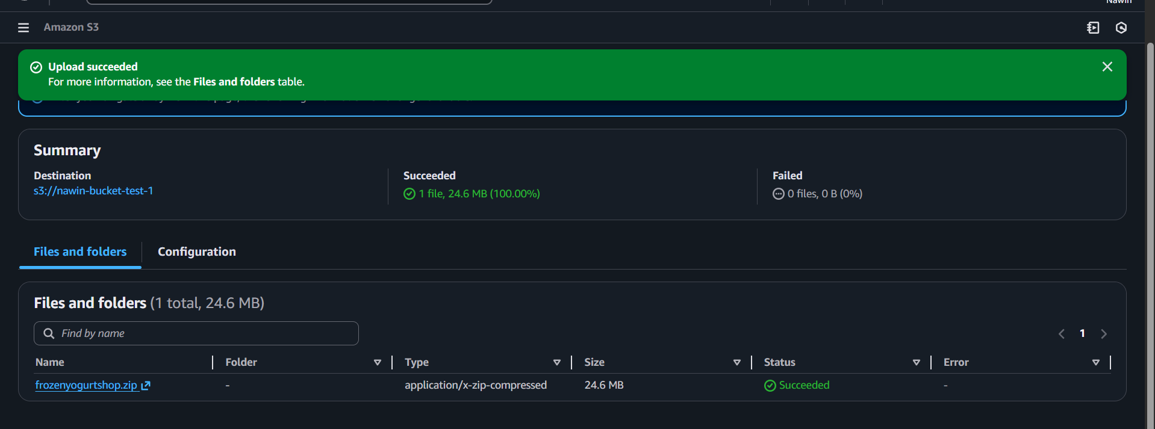

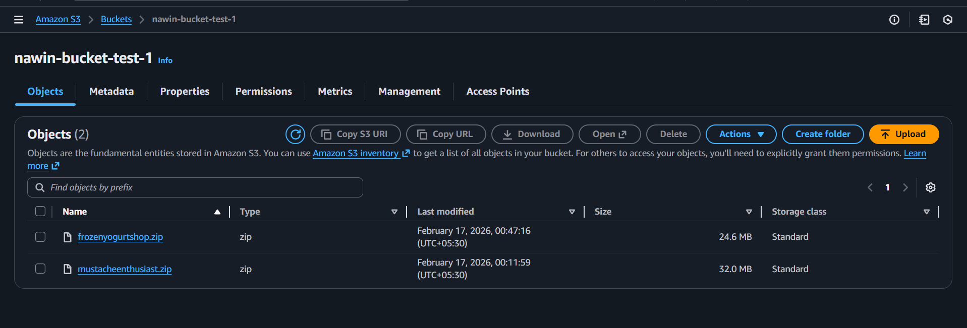
We can able to see the file upload logs from cloud watch

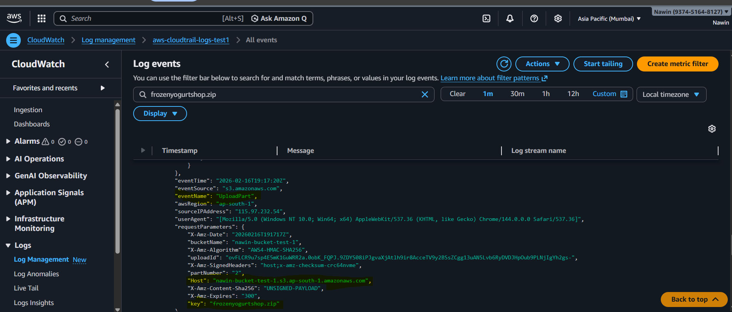

2.Launch two ec2-instances and connect it to a application load balancer, where the output traffic from the server must be an load balancer IP address

Created two EC2

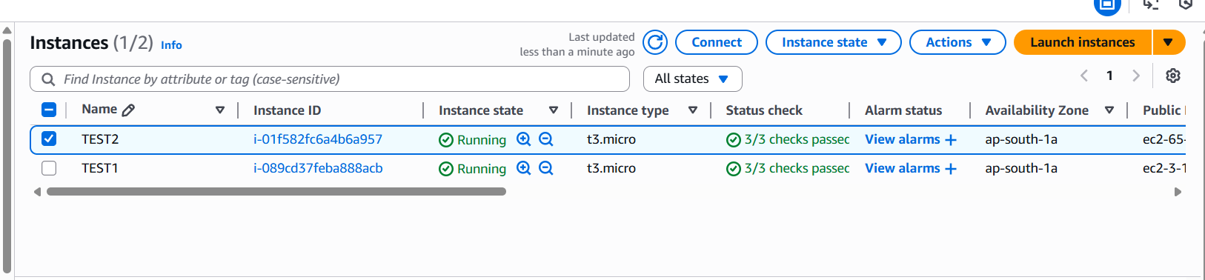

Created ALB
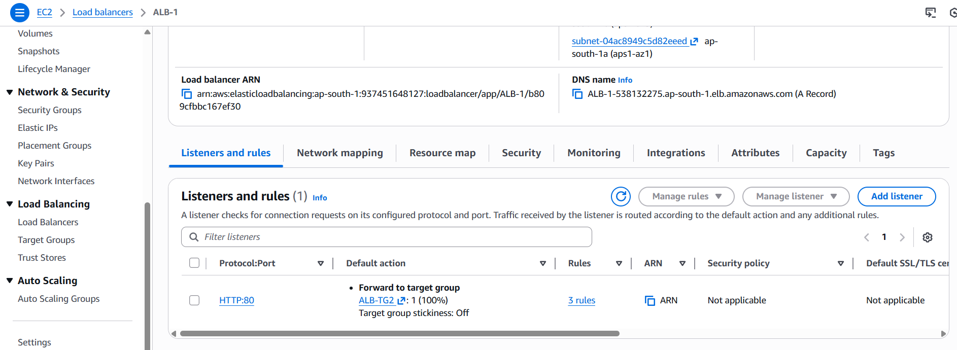

Created Listener Rules inside the ALB
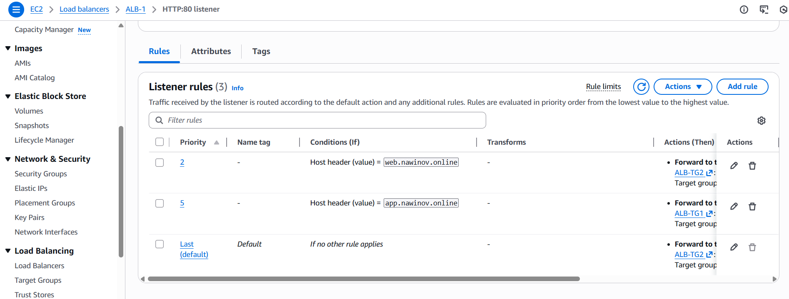

Inbound Rules in Security Groups
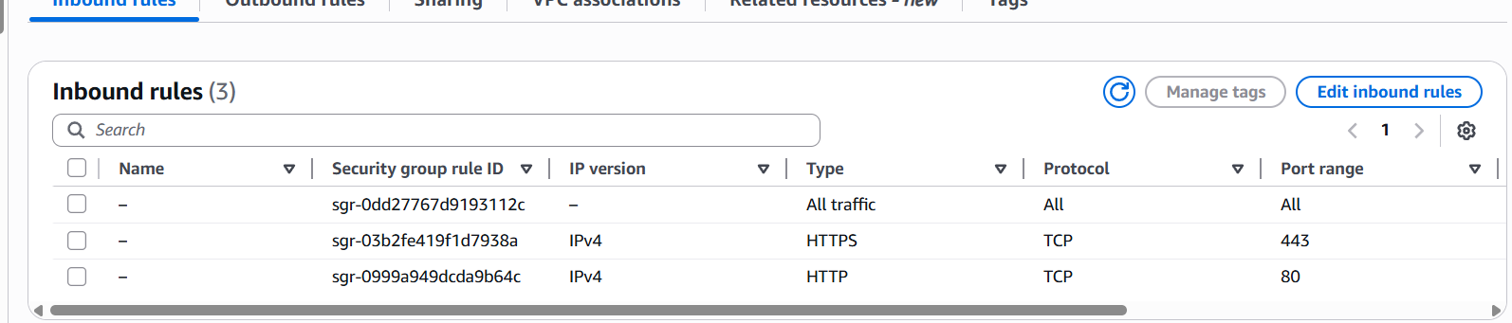

Updated the DNS conditions DNS
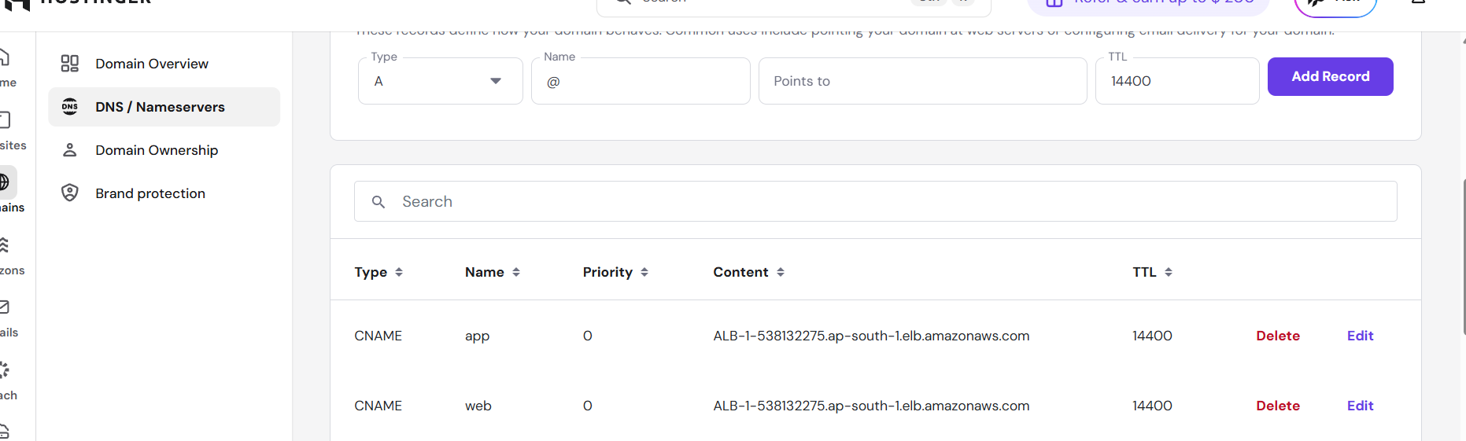

Outbound Traffic Check:
Elastic IP assigned automatically for ALB
